GUIDED TOUR OF THE
KINSELLA LIBRARY
(A Hidden Gem)
PAINTINGS BY
CALIFORNIA PLEIN AIR ARTISTS
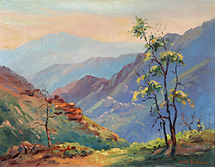
Wed., Jan. 9 or Fri., Jan. 18, 10:30 am
Kinsella Library 1134 Kline St., La Jolla
Lunch following at a location to be announced
Each tour is limited to 20 participants. After 20, sign up to be wait-listed.

